WW1 project : Erin Marmion

World War One was a global war originating in Europe that lasted from 28 July 1914 to 11 November 1918. Contemporaneously known as the Great War or “the war to end all wars” it led to the mobilisation of more than 70 million military personnel, including 60 million Europeans, making it one of the largest wars in history. It is also one of the deadliest conflicts in history, with an estimated 9 million combatant deaths and 13 million civilian deaths as a direct result of the war, while resulting genocides and the related 1918 Spanish flu pandemic caused another 17–100 million deaths worldwide, including an estimated 2.64 million Spanish flu deaths in Europe and as many as 675,000 Spanish flu deaths in the United States.

On 28 June 1914, Gavrilo Princip, a Bosnian Serb Yugoslav nationalist, assassinated the Austro-Hungarian heir Archduke Franz Ferdinand in Sarajevo, leading to the July crisis. In response, Austria-Hungary issued an ultimatum to Serbia on 23 July. Serbia's reply failed to satisfy the Austrians, and the two moved to a war footing. A network of interlocking alliances enlarged the crisis from a bilateral issue in the Balkans to one involving most of Europe. By July 1914, the great powers of Europe were divided into two coalitions: The Triple Entente, consisting of France, Russia, and Britain; and the Triple Alliance of Germany, Austria-Hungary, and Italy. The Triple Alliance was only defensive in nature, allowing Italy to stay out of the war until April 1915, when it joined the Allied Powers after its relations with Austria-Hungary deteriorated. Russia felt it necessary to back Serbia, and approved partial mobilisation after Austria-Hungary shelled the Serbian capital of Belgrade, which was a few miles from the border, on 28 July.

Dogs played an important military role for most European armies during World War 1, serving in a variety of tasks. Dogs hauled machine guns and supply carts. They also served as messengers, often delivering their missives under a hail of fire.
Sergeant Stubby (1916 – March 16, 1926) was a dog and the official mascot of the 102nd Infantry Regiment ( United States) and was assigned to the 26th (Yankee)Division in World War 1. He served for 18 months and participated in 17 battles on the Western Front. He saved his regiment from surprise mustard attacks, found and comforted the wounded, and allegedly once caught a German soldier by the seat of his pants, holding him there until American soldiers found him. His actions were well-documented in contemporary American newspapers.
Stubby has been called the most decorated War Dog of WWI and the only dog to be nominated for rank and then promoted to sergeant through combat. Stubby's remains are in the Smithsonian Institution. He was extraordinarily made a Sergeant, roughly notable to the Dicken Medal which had not yet come into existence. Stubby served with the 102nd Infantry Regiment in the trenches in France for 18 months and participated in four offensives and 17 battles. He entered combat on February 5, 1918, at Chemin des Dames north of Soissons, and was under constant fire, day and night for over a month. In April 1918, during a raid to take Seicheprey, Stubby was wounded in the foreleg by retreating Germans throwing hand grenades. He was sent to the rear for convalescence and, as he had done on the front, improved morale. When he recovered from his wounds, Stubby returned to the trenches. In his first year of battle, Stubby was injured by mustard gas. After he recovered, he returned with a specially designed gas mask to protect him. Thus, learning to warn his unit of poison gas attacks, locate wounded soldiers in no man's land and-since he could hear the wine of incoming artillery shells before humans—became very adept of alerting his unit when to duck for cover. He was solely responsible for a German spy in the Argonne, leading their unit’s commander nominating Stubby for the rank of Sergeant Following the retaking of Château-Thierry by the US, women of the town made Stubby a chamois coat upon which his many medals were pinned. He was later injured again, in the chest and leg by a grenade. He ultimately had two wound stripes.
At the end of the war, Robert Conroy smuggled Stubby home. In 1926, Stubby died of old age in Conroy's arms. He had become perhaps the most famous of World War I military dogs. His obituary ran in several newspapers. Sergeant Stubby was not buried but instead rests at the Price of Freedom exhibit in the National Museum of American History where he and his story are on display.

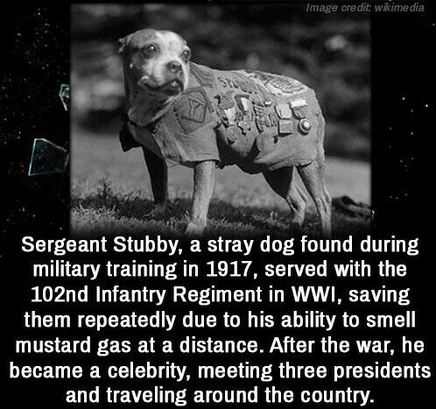

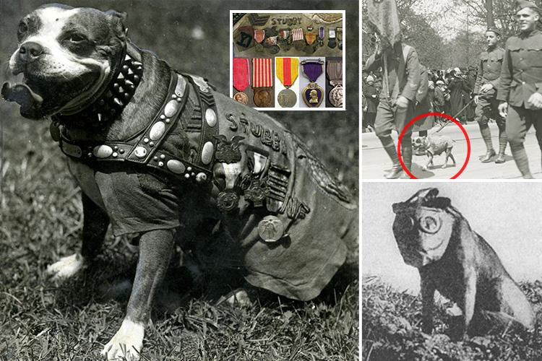
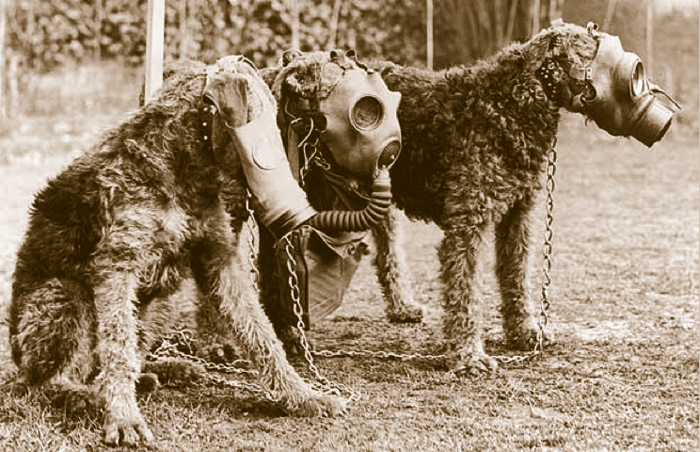

In the war if you got injured, you’d have to rely on your friends to bring you back to the trenches to get seen by the doctor. Sick patients were given an anaesthetic called morphine. If you went into shock you were given tea because it was sweet and it was familiar, it was reassuring for them.
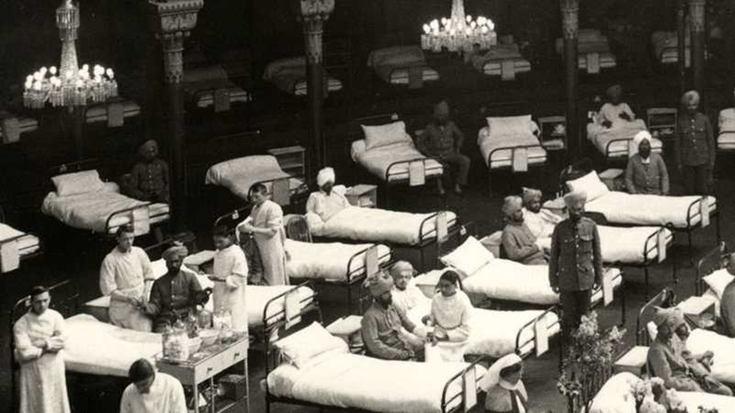

The honour cross of the world war 1914/1918, commonly, but incorrectly, known as the Hindenburg cross was established by Field Marshal von Hindenburg, President of the German Republic, by an order dated 13 July 1934, to commemorate service of the German people during the First World War. This was Germany's first official service medal for soldiers of Imperial Germany who had taken part in the war, and where they had since died it was also awarded to their surviving next-of-kin. Shortly after its issuance, the government of Nazi Germany declared the award as the only official service decoration of the First World War and further forbade the continued wearing of German Free Corps Awards on any military or paramilitary uniform of a state or Nazi Party organization. The Honour Cross was modelled on the reverse side of the Ear Commerative Medal of 1870/71 (Preußen Kriegsdenkmünze 1870-1871), and was designed by Eugene Godet. The medal awarded to combatants (the Frontkämpferkreuz) displayed a laurel wreath encircling a medallion, with the dates 1914/1918". Crossed swords are between the arms. The reverse side was plain, except for the manufacturer's logo. The Honour Cross for non-combatants has no swords and a wreath of oak leaves. Both crosses are in bronze. The Honour Cross for Next-of-Kin (commonly known as the Widows Cross), was finished in black.
The Honour Cross was worn suspended from a ribbon with black edge stripes, two white stripes, two black stripes and a red stripe in the middle between them. The ribbon for the Honour Cross for Next-of-Kin had these colours in a different order, having a white edge stripes, with two black stripes, white stripes on either side of a red stripe in the middle.
They were frequently worn with the ribbon fashioned into a bow, with a pin on the back, which the mother or widow in question attached to her clothing. The application for this award had a time limit, which expired at the end of 1942. Each award came with an Urkunde, or certificate, which indicated which form the award took. The certificates for the next-of-kin crosses came in two types: those for widows were titled Ehrenkreuz für Witwen (Honour Cross for Widows), those for parents Ehrenkreuz für Eltern (Honour Cross for Parents). The award was ranked above other service and occupation medals, but below other awarded combat medals.
The number of awards given was:
. for combatants 6,202,883
. for non-combatants 1,120,449
. for widows 345,132
. for parents 372,950
. total 8,041,414
By a decree dated 30 November 1938, the State Minister of the Interior introduced these awards into the Ostmark (the name of Austria after it was annexed by Nazi Germany). By 1940, it had also been approved for persons of German heritage from seized lands of the Sudetenland,
Czechoslovakia, Danzig, Saar and Memel. Awarding of the cross to war participants of German heritage continued after the deadline for applications had closed within the previous boundaries of Germany. Such Honour Crosses were still being awarded as late as 1944. For all attached military personnel outside these regions, the Führer, through the ordinance of 30 June 1942, had already ordered approval of these awards.

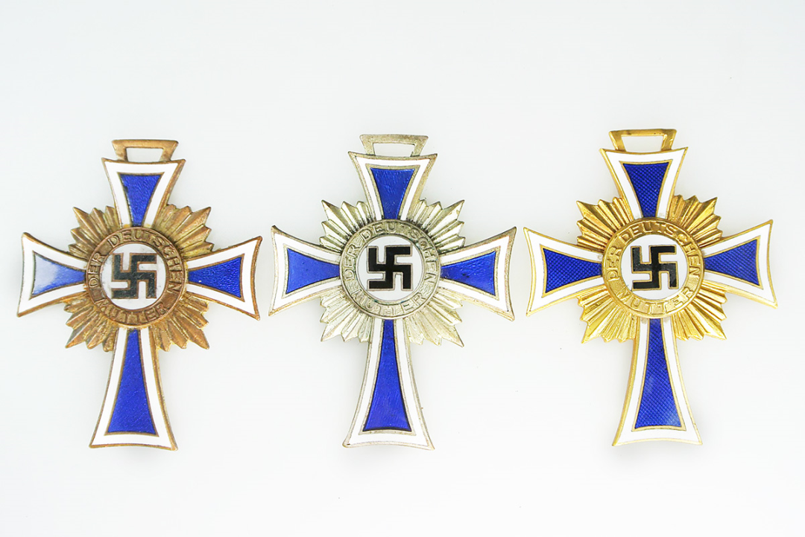

HOW THE WAR ENDED

Though Serbia was defeated in 1915 and Romania joined the allied powers in 1916 only to be defeated in 1917, none of the great powers were knocked out of the war until 1918. The 1917 February Revolution in Russia replaced the Monarchy with the provisional Government, but continuing discontent with the cost of the led to the October Revolution, the creation of the Soviet Socialist Republic and the signing of the Treaty of Brest-Litovsk by the Government in March 19/18, ending Russia’s involvement in the war. Germany now controlled much of eastern Europe and transferred large numbers of combat troops to the Western Front. Using new tactics, the German March 1918 Offensive was initially successful. The Allies fell back and held. The last of the German reserves were exhausted as 10,000 fresh American troops arrived every day. The Allies drove the Germans back in their Hundred Days Offensive, a continual series of attacks to which the Germans had no reply. One by one the Central Powers quit: first Bulgaria (September 29), then the Ottoman Empire (October 31) and the Austro-Hungarian empire (November 3).
Germany had formally surrendered on November 11, 1918, and all nations had agreed to stop fighting while the terms of peace were negotiated. On June 28, 1919, Germany and the Allied Nations (including Britain, France, Italy and Russia) signed the Treaty of Versailles, formally ending the war.
World War I was a significant turning point in the political, cultural, economic, and social climate of the world. The war and its immediate aftermath sparked numerous revolutions and uprisings.
The Big Four (Britain, France, the United States, and Italy) imposed their terms on the defeated powers in a series of treaties agreed at the 1919 Paris Peace Conference, the most well-known being the German peace treaty: The Treaty of Versailles. Ultimately, as a result of the war, the Austro-Hungarian, German, Ottoman and Russian Empires ceased to exist, and numerous new states were created from their remains. However, despite the conclusive allied victory (and the creation of the League of Nations during the peace conference, intended to prevent future wars),
A second world war followed just over Twenty years later.

