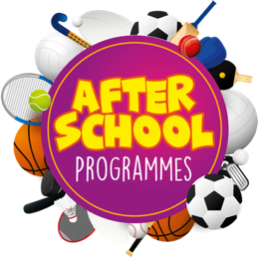
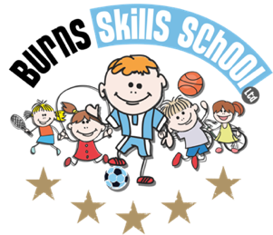
St Joseph’s PS
Meigh
Dear Parent/Guardian
We are delighted to announce that Burns Skills School are running three of their fantastic afterschool programmes within the school grounds this year. The programme will consist of 8 weeks which will entail age appropriate educational sessions that will have a main focus of fun whilst improving each child’s technical ability.
Dates of programme:

Gaelic Soccer Hip hop
Wed 20th September
Wed 27th September
Wed 11th October
Wed 18th October
Wed 8th November
Wed 15th November
Wed 22nd November
Wed 29th November
Tue 19th September
Tue 26th September
Tue 10th October
Tue 17th October
Tue 7th November
Tue 14th November
Tue 21st November
Tue 28th November

Mon 18th September
Mon 25th September
Mon 9th October
Mon 16th October
Mon 6th November
Mon 13th November
Mon 20th November
Mon 27th November

Primary 1 – Primary 3 (2.00pm-3.00pm each week) Primary 4 – Primary 7 (3.00pm-4.00pm each week)

To secure a place for your child you must make payment of £20.00 at our registration morning. A second payment of £20.00 will be due in late October. We will send out a timely reminder for this.

Registration date & time: Thursday 14th of September 8.30am

Deadline for payment is Thursday 14th September. This is a great opportunity for your child and certainly one not to be missed. When in attendance we would advise that all children wear appropriate clothing with a pair of trainers suitable for indoor and outdoor.

Payment options: Cash

Thanks
Aaron & Andrew
Burns Skills School

